
Department of Engineering Technology
Foundation University Islamabad
School of Science and Technology

Course: Introduction to Web Technology Lab
Lab II Manual
Name:
Roll no:

Topic: HTML5 Page Structure & Semantic Elements
Performance |  |  | Lab Report
Description | Total Marks | Marks Obtained | Description | Total Marks | Marks  Obtained
HTML Structure & Semantic Elements | 5 |  | Report / Screenshots & Output Validation | 5
Total Marks obtained

Lab Objectives
By the end of this lab, students will be able to:
- Understand the basic structure of an HTML5 web page.
- Use semantic HTML5 elements to create meaningful page sections.
- Add headings, paragraphs, lists, and hyperlinks to structure content.
- Validate HTML code using browser developer tools for correctness.
Step 1: Create a new HTML file
- Open VS Code.
- Create a new file index.html.
- Add the basic HTML5 structure:

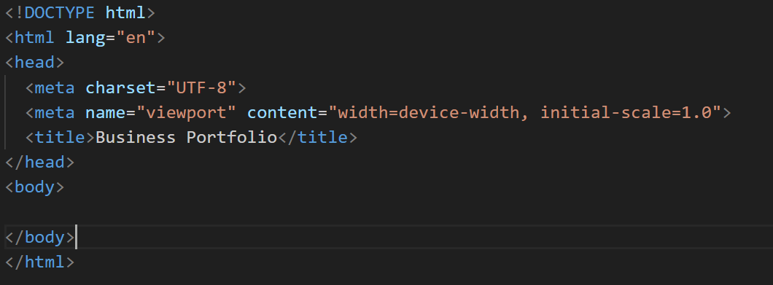

Step 2: Add Semantic Sections
- Inside <body>, add the following semantic elements:
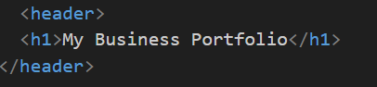
- Add NavBar

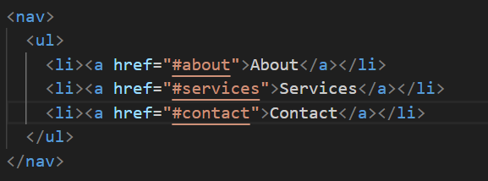
- Add Section with id=”about”

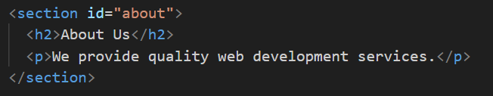
Add Another Section with id =” services”

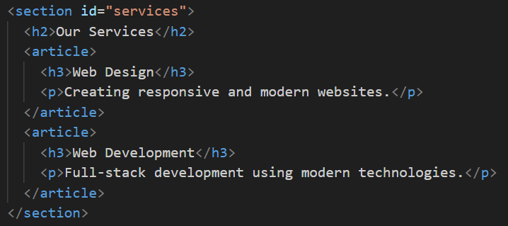

Add Footer
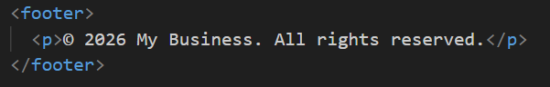

Complete Code Here:
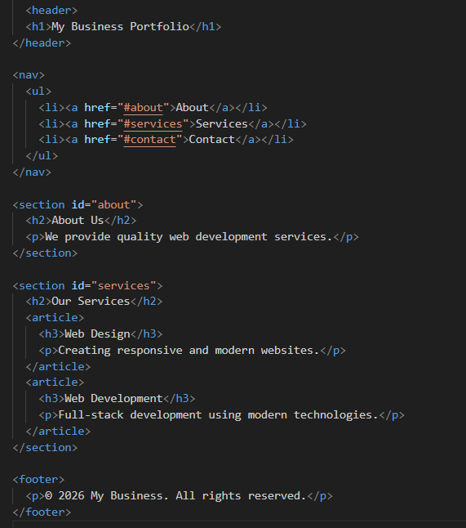
Expected Output:
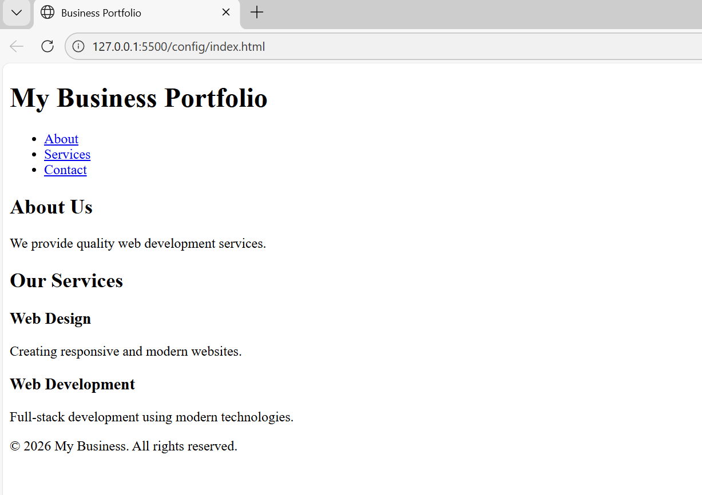

Lab Report Guidelines
Report Format and Sections:
- Make sure your report is well-organized and easy to follow.
- Use proper headings for each section mentioned above.
- Include screenshots wherever required to demonstrate progress and outputs including Figure Captions.
- Submit the lab report as a document file (Only Word)
- In next Lab You must Submit your Previous lab Report in Printed Form

